

QR-BASED CATTLE MANAGEMENT
SYSTEM: A PLATFORM FOR
PERSONALIZED HEALTH
MONITORING USING COMPOSITE
HEALTH DEVIATION INDEX (CHDI)

A Project Report

U23ADS705 – MINI PROJECT
Submitted by
SABARI KARTHICK A | (61782323110093)
SIVANARASIMMAN S | (61782323110103)
SUJEETH Y R | (61782323110107)
in partial fulfillment for the award of the degree
of
BACHELOR OF TECHNOLOGY
in
ARTIFICIAL INTELLIGENCE AND DATA SCIENCE
SONA COLLEGE OF TECHNOLOGY (AUTONOMOUS), SALEM – 636005
ANNA UNIVERSITY: CHENNAI 600 025
OCTOBER 2026

SONA COLLEGE OF TECHNOLOGY (AUTONOMOUS)
ANNA UNIVERSITY: CHENNAI – 600 025
BONAFIDE CERTIFICATE
Certified that this project titled “QR-BASED CATTLE MANAGEMENT SYSTEM: A PLATFORM FOR PERSONALIZED HEALTH MONITORING USING COMPOSITE HEALTH DEVIATION INDEX (CHDI)” is the bonafide work of “SABARI KARTHICK A (61782323110093), SIVANARASIMMAN S (61782323110103), SUJEETH Y R (617823231100107)” who carried out the project work U23ADS705 – MINI PROJECT under my supervision.

Signature of the Supervisor | Head of the Department
Ms. J. Deepika | Dr. J. Akilandeswari
Assistant Professor | Professor & Head
Department of Information Technology | Department of Information Technology
Sona College of Technology  Salem – 636005 | Sona College of Technology  Salem – 636005
Submitted for the Project Viva-Voce Examination held on ___________________

INTERNAL EXAMINER | EXTERNAL EXAMINER

Sona College of Technology
Department of Information Technology
U23ADS705 – MINI PROJECT - DECLARATION FORM
Declaration by the Student(s)
We hereby declare that the project titled “QR-BASED CATTLE MANAGEMENT SYSTEM: A PLATFORM FOR PERSONALIZED HEALTH MONITORING USING COMPOSITE HEALTH DEVIATION INDEX (CHDI)” is an original work carried out by me/us under the guidance of MS. J. DEEPIKA. This project has not been submitted elsewhere for the award of any degree.
We also affirm that all the data and information used in this project are genuine and properly acknowledged. This project work is carried out with reference to the United Nations Sustainable Development Goals: 2 – ZERO HUNGER, 9 – INDUSTRY, INNOVATION AND INFRASTRUCTURE, 3 – GOOD HEALTH AND WELL-BEING, 12 – RESPONSIBLE CONSUMPTION AND PRODUCTION.
S.No | Register Number | Name | Signature
1. | 61782323110093 | SABARI KARTHICK A
2. | 61782323110103 | SIVANARASIMMAN S
3. | 61782323110107 | SUJEETH Y R

Date: ___________________
Place: Sona College of Technology
ACKNOWLEDGMENT
First and foremost, we thank the Almighty for His blessings, guidance, and the inner peace that gave us the strength and determination to complete this project. We also express our heartfelt gratitude to our parents for their unconditional love, constant support, and encouragement throughout our journey.
We express our sincere gratitude to our beloved Chairman, Sri. C. Valliappa, and our dynamic Vice-Chairmen, Sri. Chocko Valliappa and Sri. Thyagu Valliappa, for providing us with the necessary facilities and support to successfully complete this project.
We are immensely grateful to our Principal, Dr. S. R. R. Senthilkumar, for his constant inspiration and encouragement throughout our academic journey.
We extend our sincere thanks to Dr. J. Akilandeswari, Professor and Head of the Department of Information Technology, for providing the necessary laboratory facilities and academic support to carry out this project successfully.
We express our heartfelt gratitude to our Project Coordinator, Dr. J. Jeba Emilyn, Associate Professor, Department of Information Technology, for her continuous guidance, valuable suggestions, and constant encouragement throughout the project.
We are also deeply grateful to Ms. J. Deepika, Assistant Professor, Department of Information Technology, for her invaluable mentorship, insightful guidance, and unwavering support throughout the project. Her expertise and constructive suggestions have played a significant role in shaping our work and helping us achieve our objectives.
Finally, we take this opportunity to express our sincere appreciation to all the faculty members, non-teaching staff, and friends who supported us, either directly or indirectly, in completing this project successfully. Their cooperation and encouragement have contributed greatly to the successful completion of our work.
ABSTRACT
The use of precision livestock health monitoring in smallholder dairy farms is frequently limited by the price of specific RFID readers, specific and proprietary wearable sensors, or fixed thresholds across a herd. These conventional approaches frequently trigger false alarms by failing to account for individual cattle physiological variations and sparse field data.
To solve this problem, a platform called QR Based Cattle Management System is designed, which is an infrastructure-light cloud based cattle health monitoring system with the Composite Health Deviation Index (CHDI) to monitor the dairy health status based on personalized parameters of the herd. The system eliminates the need for costly hardware and makes use of weather-resistant QR passports that can be accessed with standard smart devices and backed by Role Based Access Control (RBAC). It contains a Three-Stage Adaptive CHDI engine at its core, which sets an individual baseline of 14-days, calculates multivariate Mahalanobis distance deviations, calculates 7-day temporal trend slopes, generates explainable feature attributions and applies an uncertainty gate to suppress false alarms during early enrollment.
The application is a modern full-stack solution built with Next.js (App Router, Route Handlers), hosted on the Dockerized Neondb PostgreSQL database with Neon, using a dedicated FastAPI Python analytical microservice, and a responsive web application that provides real-time mobile QR scanning and veterinary triage workflows.System evaluation results show 90.48% sensitivity, 96.27% specificity, 62.30% precision and an F1 score of 73.79% in the detection of sub-clinical health
anomalies leading to an advance clinical lead time of 2-4 days before the clinical symptoms.
TABLE OF CONTENTS
1. 1. INTRODUCTION | 1
1.1 Background of the Project | 1
1.2 Problem Statement | 1
1.3 Motivation | 2
1.4 Objectives | 2
1.5 Scope of the Project | 3
2. LITERATURE REVIEW | 4
2.1 Introduction | 4
2.2 Review of Related Studies | 4
2.3 Techniques and Technologies Used in Existing Systems | 7
2.4 Research Gap | 7
2.5 Summary | 8
3. CHAPTER 1 – NEED FOR PROPOSED TECHNIQUE | 9
3.1 Existing Techniques | 9
3.2 Limitations of Existing Techniques | 9
3.3 Proposed Technique | 9
3.4 Objectives of the Proposed Technique | 10
3.5 Advantages of the Proposed Technique | 10
4. CHAPTER 2 – DESIGN OF PROPOSED SYSTEM AND ITS IMPLEMENTATION | 11
4.1 Introduction | 11
4.2 System Requirements | 11
4.2.1 Hardware Requirements | 11
4.2.2 Software Requirements | 11
4.3 System Architecture | 12
4.4 System Modules | 13
4.4.1 Module 1: User Authentication and Access Control Module | 13
4.4.2 Module 2: Cattle Identification and Management Module | 13
4.4.3 Module 3: Cattle Health Data Logging Module | 14
4.4.4 Module 4: Medical and Vaccination Management Module | 14
4.4.5 Module 5: Health Baseline and CHDI Calculation Module | 14
4.4.6 Module 6: Health Trends and Weekly Analytics Module | 14
4.4.7 Module 7: Health Analysis and Explainability Module | 15
4.4.8 Module 8: Veterinary Alerts & Feedback Learning Module | 15
4.5 Proposed Methodology | 15
4.6 System Workflow | 15
4.7 Techniques Used | 16
4.8 Data Collection | 22
4.9 Data Preprocessing | 23
4.10 Model Development | 24
4.11 System Design Diagrams | 25
4.12 Implementation | 27
4.13 Coding Implementation | 27
4.14 User Interface Screens | 34
4.15 Chapter Summary | 37
5. CHAPTER 3 – RESULTS AND DISCUSSION | 38
5.1 Introduction | 38
5.2 Experimental Setup | 38
5.3 Evaluation Metrics | 38
5.4 Experimental Results | 39
5.5 Comparison with Existing Techniques | 42
5.6 Discussion of Results | 43
5.7 Chapter Summary | 43
6. CHAPTER 4 – CONCLUSION AND FUTURE SCOPE | 44
6.1 Summary of the Project | 44
6.2 Conclusion | 44
6.3 Future Scope | 44
SDG GOALS | 45
REFERENCES | 47

LIST OF FIGURES
Figure No. | Figure Title | Page No.
4.1 | Overall System Architecture | 13
4.2 | System Workflow and Health Analysis | 16
4.3 | CHDI Baseline and Anomaly Detection | 22
4.4 | CHDI System Design | 25
4.5 | Regional Heatmap and Outbreak Detection | 26
4.6 | Farmer Dashboard | 34
4.7 | Cattle QR Scanner and Digital Identity | 35
4.8 | Cattle Health Records and CHDI History | 35
4.9 | Veterinary Health Assessment Interface | 36
4.10 | Cattle List and Health Status | 37
5.1 | CHDI Health Status Distribution | 39
5.2 | CHDI Trend Showing Early Health Alerts | 41
5.3 | Feature Importance for Health Anomaly Detection | 41
LIST OF TABLES
Table No. | Table Title | Page No.
4.1 | Hardware Requirements | 11
4.2 | Software Tools and Technologies | 12
4.3 | CHDI Levels and Clinical Actions | 17
4.4 | Health Indicators and Normal Values | 23
4.5 | GitHub Repository Structure | 28
5.1 | Anomaly Detection Performance Metrics | 40
5.2 | Comparison with Existing Health Monitoring Methods | 42
5.3 | CHDI Component Ablation Study | 42

LIST OF ABBREVIATIONS
Abbreviation | Full Expansion
API | Application Programming Interface
BRD | Bovine Respiratory Disease
CHDI | Composite Health Deviation Index
F1 | Harmonic Mean of Precision and Recall
IoT | Internet of Things
LF | Low Frequency
ML  CMT | Machine Learning  California Mastitis Test
OLS | Ordinary Least Squares
ORM | Object-Relational Mapping
PLF | Precision Livestock Farming
QR | Quick Response Code
RBAC | Role-Based Access Control
RFID  WSN | Radio-Frequency Identification  Wireless Sensor Network
UHF | Ultra-High Frequency
UI  LOCO | User Interface  Leave-One-Covariate-Out

1. INTRODUCTION
1.1 Background of the Project
Smallholder dairy farming is a key socio-economic pillar of global livestock production and rural economies. In India, livestock farming plays a crucial role in agriculture by providing nutritional security and regular income to farmers. Despite its economic importance, dairy farming faces several challenges due to the silent onset of sub-clinical diseases, delays in veterinary diagnosis and the high cost of commercial Precision Livestock Farming (PLF) systems. Diseases such as sub-clinical bovine mastitis, bovine respiratory disease (BRD) and metabolic disorders can cause reduced milk production, increased veterinary expenses and early culling of valuable cows. Research has explored sensor-based monitoring and machine learning techniques for the early detection of cattle health problems [5], [8]. Although electronic identification and wearable biosensors are useful, commercial monitoring systems can be expensive for smallholder farmers [2], [14]. Therefore, an infrastructure-light, sensor-optional and affordable health monitoring solution that works on ordinary mobile devices is needed.
1.2 Problem Statement
Smallholder dairy farmers and rural veterinary personnel often lack access to affordable, accessible and reliable digital tools for livestock monitoring. There are three major problems that need to be addressed.
1. Expensive RFID Systems: Passive Low-Frequency (LF) or Ultra-High-Frequency (UHF) RFID ear tags and reader antennas can be expensive for small farmers, particularly those managing fewer animals. This makes existing cattle tracking systems difficult to adopt in farms without automated facilities.
2. Fixed Thresholds and False Alarms: Standard monitoring systems may use fixed thresholds to identify health problems. However, body weight, milk yield, feed intake and temperature naturally vary between individual cows, breeds and lactation stages. These differences can lead to unreliable alerts.
3. Limited Farm Data: Rural farm data collection is often limited or irregular, and environmental conditions can affect the collected information. Without sufficient historical data for newly registered cows, health predictions may be unreliable. Therefore, the system needs a mechanism to avoid generating alerts when the available data is insufficient.
1.3 Motivation
The main objective of the project is to make precision livestock health monitoring accessible to smallholder dairy farmers through an infrastructure-light, cloud-native software platform. The proposed system uses QR digital passports instead of expensive proprietary identification hardware, allowing cattle records to be accessed through a smartphone camera. QR-based cattle identification has been explored as an approach to animal identification [4]. Research on precision livestock monitoring and machine learning also demonstrates the potential of data-driven approaches to cattle health assessment [2], [5], [8]. Building on these approaches, the proposed system replaces rigid thresholds with a personalized Three-Stage Composite Health Deviation Index (CHDI) engine. This engine aims to identify unusual changes in cattle health, provide understandable alerts and support veterinary triage without requiring specialized health-monitoring hardware.
1.4 Objectives
The following are the key objectives of the proposed system:
1. Infrastructure-Independent Livestock Identification: To create a secure QR animal passport linked to cloud-based health records and accessible through a smartphone camera instead of expensive RFID readers.
2. Personalized Longitudinal Baseline Modeling: To design and implement a multivariate Mahalanobis distance-based Three-Stage Composite Health Deviation Index (CHDI) engine that creates a personalized 14-day rolling physiological baseline and identifies deviations in the recorded health signals.
3. Explainability and Uncertainty Estimation: To apply ordinary least-squares regression for analyzing 7-day health trends, implement a data-sufficiency gate to reduce unreliable alerts during early enrollment, and use leave-one-covariate-out (LOCO) feature attribution to explain the factors contributing to detected health deviations.
4. Automated Clinical Triage Pipeline: To develop a veterinary case management workflow that prioritizes critical cases, routes urgent cases to attending veterinarians, records veterinary feedback for continuous improvement and tracks clinical diagnoses.
5. Full-Stack Web Application Prototype: To design and develop a web application using Next.js App Router and API Route Handlers, Prisma ORM, PostgreSQL and a dedicated FastAPI Python microservice, with mobile-friendly interfaces for farmers and veterinarians.
1.5 Scope of the Project
The project includes the design, mathematical modeling, development and evaluation of the proposed platform. It features QR-based cattle identification, longitudinal health data logging, anomaly detection (via CHDI), trend analysis over time, and clinical triage and role-based dashboards. The health records contain parameters like body weight, feed intake, milk production and temperature, which can be used to monitor health individually. The platform is tested with data of 16 Holstein-Friesian cows with 674 longitudinal observation records. The purpose of the system is to enable farmers to detect abnormalities in their animals' health early on and facilitate veterinary care.

2. LITERATURE REVIEW
2.1 Introduction
Cattle management requires proper identification, accurate health records, regular observation, and timely veterinary support. Precision Livestock Farming uses sensors, cameras, machine learning, and digital records to improve cattle monitoring. The proposed QR-Based Cattle Management System maintains individual cattle profiles and uses the Composite Health Deviation Index (CHDI) to identify possible health deviations and support veterinary follow-up.
2.2 Review of Related Studies
Ankitha, et al. [1] provided data on clinical mastitis detection with Udder parameters, the IoT and Thermal imaging. Their work focuses on the use of technology in monitoring cattle health.
Aquilani et al. [2] reviewed the technologies of Precision Livestock Farming in pasture based livestock systems. They note in their review how digital technologies can enhance livestock monitoring and management.
Barriuso et al. [3] explored a multi-agent systems and wireless sensor network (WSN) synergy for monitoring cattle. Their efforts illustrate how connected technologies can help gather livestock data.
Bumbálek et al. [4] evaluated several different identification techniques for cattle, such as collars with QR-codes, numerical ear tags and body texture. Their research has identified the need for sound animal identification. QR codes could be used to link specific animals with digital records.
Curti et al. [5] studied algorithms based on machine learning in individual cow health records, to predict disease. They work to enable the use of historical health data in the identification of potential health issues.
Falalu et al. [6] discussed about the optical QR verification versus RFID in the smart livestock management. Their work is related to using QR-based identification as an alternative identification hardware.
Fan et al. [7] performed anomaly detection for personalised continuous physiological data. They have also been working on the idea of noticing unusual changes in individual patterns of data.
Garg et al. [8] studied multi-parametric machine-learning models for early prognosis of bovine diseases. They have shown that the potential exists to use the combination of several indicators for cattle health monitoring.
Gupta and Bansal [9] studied encrypted QR based digital passporting of cattle. Their work is centred around the safe association of animal identification with digital record.
Hostens et al. [10] provided a longitudinal dataset with dairy cattle production, physiological and behavioural data. These types of data can aid research on cattle health and behaviour across time. Using data from the automatic milking system for detecting clinical mastitis,
Kamphuis et al. [11] studied various decision-tree approaches. Their work shows how they used information they collected about the production to try to identify any health issues that might arise.
Kaur and Virk [12] introduced a smart neck collar for IoT-based diseases detection and health monitoring of dairy cow. Their work provides evidence of connected devices' use for livestock monitoring.
Kim et al. [13] have introduced a new dataset on dairy cattle monitoring and Precision Livestock Farming, called MmCows. They have shown how important it is to use data from cattle to monitor and study them.
Kumar and Sharma [14] discussed the availability of Precision Livestock Farming technologies to the smallholder dairy farmers in developing countries. Their efforts are focused on the need for affordability and accessibility.
Mehta et al. [15] investigated clinical machine learning in veterinary medicine through selective classification and abstention. This strategy is similar to the one of trying to make a prediction if data is lacking that may be unreliable.
Pereira et al. [16] carried out an in-depth review on passive UHF RFID technologies for animal tracking. Their work helps to place electronic identification systems in livestock management into perspective.
Qureshi et al. [17] examines the spatial epidemiology and early outbreak detection of bovine diseases using density based clustering. Their work is an excellent example of how data analysis can be used to help pinpoint any possible pattern in the disease.
Subach and Shmeleva [18] talked about implementation of digital innovations in livestock production. Their operations shed light on the significance of digital means in contemporary livestock operations.
Thakur and Chakre [19] summarized the state of the art research on a dairy health monitoring system using artificial intelligence and sensor fusion. Their research points to the possibilities of using multiple data sources in health assessment.
Waldron [20] discussed about the biotelemetry context of statistical frame theory and multivariate anomaly detection. The present invention is related to statistical techniques for detecting rare instances of multivariate data.

2.3 Techniques and Technologies Used in Existing Systems
The key methods that need to be considered in cattle management are:
1. Individual cattle information is available via QR and Digital Identification: QR-code collars and digital passporting [4],[ 9].
2. Sensor-Based Monitoring: Wireless sensor networks, IoT collars and livestock-tracking technologies are used to gather data about the cattle [3], [12], [16].
3. Machine Learning: Machine-learning techniques can be used for disease prediction, mastitis detection and monitoring of cattle health [5],[8],[11].
5. Multimodal Monitoring: Multi-modal data from production, physiological and behavioural monitoring are combined to enable broader cattle monitoring [10],[ 13], [19].
6. Anomaly Detection and Data Sufficiency: The personalized anomaly detection and selective classification approaches are helpful to detect the unusual patterns and avoid the unreliable prediction [7], [15], [20].
2.4 Research Gap
The literature review serves as the foundation for cattle identification through QR codes, electronic cattle records, sensor monitoring, and data analysis for cattle health. Based on these research areas, the following areas are considered in the design of the proposed system:
1.Integration of Identification and Health Records: Bumbálek et al. [4] were interested in the identification of cattle by QR-code collars and Curti et al. [5] in machine learning from individual cow health records. The proposed system is a hybrid of cattle identification and access to individual digital profiles and health records.
2. Personalised Health Monitoring: Fan et al. [7] investigated personalised anomaly detection and Hostens et al. [10] offered historical cattle data. These areas are expanded upon by the proposed CHDI approach, which involves comparing a number of recorded health indicators to the animal's historical baseline health data, instead of using only population-level health thresholds.
3. Multivariate Anomaly Detection: Kim et al. [13] introduced a multimodal dataset for monitoring cattle and Waldron [20] talked about multivariate anomaly detection. The proposed CHDI engine utilizes multiple health indicators to detect deviations with the goal of uncovering potentially unusual health patterns.
4. Insufficient Historical Data: Mehta et al. [15] proposed to solve the problem of selective classification and abstention. To this end, the proposed system introduces a data-sufficiency check, based on this concept, to decide on the sufficient number of historical observations to conduct reliable health assessment. The availability of precision livestock technologies for smallholder farmers was discussed by Kumar and Sharma [14] and digital innovations in livestock farming by Subach and Shmeleva [18]
5. Integrated Digital Livestock Management: The proposed system combines identification via QR codes, individual health records, deviation analysis based on CHDI with role-based access into a single platform that would enable farmers and vets to manage and adhere to cattle management and health follow-up.
2.5 Summary
This chapter reviewed twenty studies on cattle identification, sensor-based monitoring, machine learning, anomaly detection, and digital livestock management. The proposed system combines QR-based identification, individual digital records, role-based access, and CHDI-based monitoring to support organised cattle management and timely veterinary follow-up.
3. CHAPTER 1 – NEED FOR PROPOSED TECHNIQUE
3.1 Existing Techniques
Regular manual checkup by the farmers (eyes are dull, cud chewing is reduced, walking is changed, or udders are swollen) and occasional visits by veterinary officers are used in conventional livestock health management in smallholder dairy farming. Large commercial herds use automated monitoring based on passive RFID tags, walk-through antenna gates and proprietary collars (wearable items) that have fixed numerical thresholds.
3.2 Limitations of Existing Techniques
Existing technologies have significant constraints and these constraints adversely impact the productivity of smallholders:
- Delayed Detection: When tissue damage and/or significant loss of milk occurs due to subclinical signs of mastitis and ketosis, treatment is less effective.
- High Capital Cost: Commercial RFID and IoT sensor collar systems have high capital cost, need to replace batteries frequently, and are locked into vendor systems.
- High Spurious Alarm Rates: Fixed population thresholds result in unnecessary spurious alarms when temperatures get hot during the day and during seasonal variations, leading to alarm fatigue.
- Broken Paper Records: Some veterinary history, vaccination dates and the time period for antibiotic use are documented on loose paper slips that carry a risk of antibiotic residues being present in commercial milk.
3.3 Proposed Technique
The proposed technique introduces a QR-based cattle health management system an infrastructure-light, sensor-optional, cloud-native dairy health management system. The platform provides a safer, cheaper and more durable alternative to costly hardware, enabling the scanning of dynamic QR digital passports using any standard smartphone camera. An adaptive Three-Stage Composite Health Deviation Index (CHDI) engine assesses daily multi-signal health logs (daily milk yield, minutes in rumen, core body temperature, physical activity, feed intake, and body weight). CHDI calculates multivariate Mahalanobis distance anomalies, and implements a data-sufficiency abstention gate to reduce false alarms at the start of enrollment, while tracking personalized 14-day rolling baselines.
3.4 Objectives of the Proposed Technique
The major goals of the proposed technique are:
- Infrastructure-Light Traceability: No specialized RFID wands required, and 100% commodity smartphones can scan QR codes.
- Adaptive Anomaly Scoring: Calculate real-time CHDI scores (0-100), based on each cow's baseline.
- Dual-Tier Explainability: Provide simple explanations to farmers and technical explanations to vets using the Z-Scores.
- Closed-Loop Clinical Triage: Automate priority VetCase dispatch, diagnosis confirmation, treatment recording and active-learning classifier retraining.
3.5 Advantages of the Proposed Technique
The proposed method has unique operational, clinical and cost benefits:
- Near-Zero Hardware Cost: Leverages mobile web browsers already owned by farmers, and printable QR tags.
- No false alarm (96.27% of High Diagnostic Specificity) using Mahalanobis multi-signal covariance modeling.
- Active Learning Feedback Loop: Veterinarians confirm diagnosis, retrain a Scikit-learn Random Forest model with confirmed past results.
4. CHAPTER 2 – DESIGN OF PROPOSED SYSTEM AND ITS IMPLEMENTATION
4.1 Introduction
This chapter describes technical design and implementation of proposed QR-Based Cattle Health Management System. It explains the general system construction, the mathematical models applied by the CHDI engine, the hardware and software needs, eight main modules, workflows, database design, and implementation.
4.2 System Requirements
4.2.1 Hardware Requirements
The platform has been designed in such a way that the end-user will never have to rely on any proprietary hardware. The commodity client hardware and cloud server infrastructure that were used in the system are detailed in Table 4.1.
Table 4.1: Hardware Requirements
Hardware Component | Specifications & Configuration | Functional Role
Client Smartphone / Tablet | Android/iOS device with a camera and web browser | Scans QR codes, records cattle health data, and accesses the dashboard..
Weather-Resistant QR Tags | Laminated, UV-resistant QR ear tags or neck tags | Provides affordable, unique identification for each animal..
Cloud Backend Server | Cloud-based server with suitable processing, memory, and storage resources | Hosts the web application, health analytics service, and database..
4.2.2 Software Requirements
The software architecture is built on the top of modern web standards, type-safe frameworks, and highly efficient analytical libraries as outlined in Table 4.2.
Table 4.2: Software Tools and Technologies
Software Layer | Technology | Configuration
Frontend Web Application | Next.js 16, React 19, TailwindCSS | App Router, UI components, Recharts
Backend API & Logic | Next.js API Routes, Node.js, Prisma ORM | REST APIs, authentication, session guards
ML & Analytics Microservice | FastAPI, NumPy, SciPy, Scikit-learn, Pandas | CHDI calculation, LOCO attribution, Random Forest
Relational Database | PostgreSQL (Neon Serverless) | Cattle records, health logs, vet cases
QR Code Engine | qrcode (npm), HTML5 Canvas | QR generation and cattle record access
4.3 System Architecture
The proposed system architecture is divided into four decoupled layers which are Decentralized Physical Identity Layer, Secure Application & Persistence Layer, CHDI Analytical Microservice Layer and the Role Based Presentation Layer, as shown in Figure 4.1.
1. Physical Identity Layer: Optical QR tags contain unique cryptographic tokens within health profiles in the cloud for each cattle.
2. Application & Persistence Layer: Next.js Server Actions validate input, perform RBAC security checks and write time-series logs into PostgreSQL with Prisma ORM.
3. Analytical Microservice Layer: The Python FastAPI service computes 14-day rolling statistics, Mahalanobis CHDI distances, 7-day OLS slope trajectories, permutation feature attributions and uncertainty gates.
4. Presentation Layer: Responsive web interfaces with role-based dashboards for farmers, veterinarians, to manage cattle records, health information, and clinical alerts.
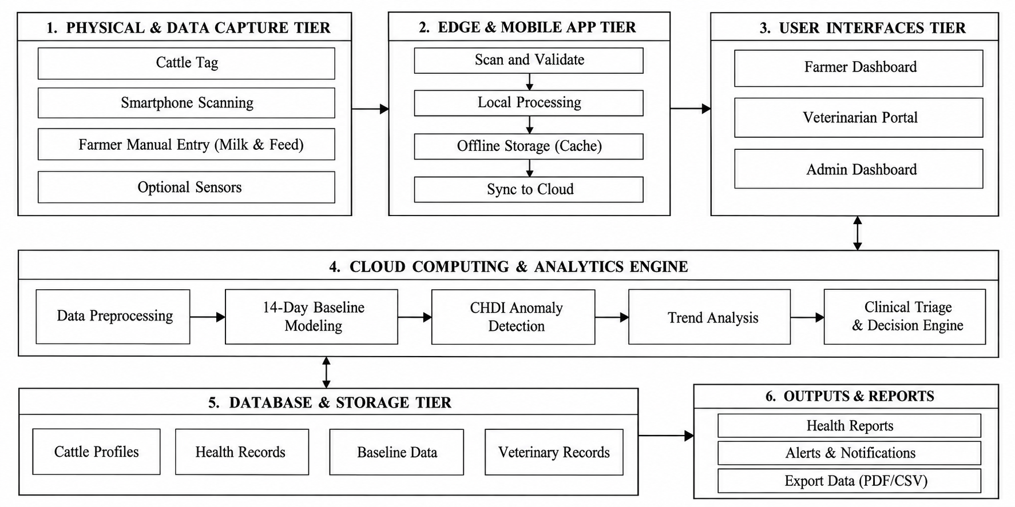
Figure 4.1: Overall System Architecture
4.4 System Modules
The designed system is broken down into eight specialized and decoupled functional modules:
4.4.1 Module 1: User Authentication and Access Control Module
Module 1 controls access and security for users in three roles: Farmer (herd management, health logging and profile updates); Veterinarian (clinical triage, diagnosis, treatment logging and feedback verification); and Administrator (herd analytics, user management, audit trails and configuration of CHDI thresholds). NextAuth session tokens implement route protection based on roles.
4.4.2 Module 2: Cattle Identification and Management Module
In Module 2, cattle on-boarding, breed categorisation, tracking of lactation stage and optical generation of QR passport is managed. A unique cryptographic token (`qrToken`) is created for each cattle profile and displayed as an SVG/PNG QR code. The digital passport is immediately resolved through the QR code without login and medical record edits are made with the authentication of a veterinarian.
4.4.3 Module 3: Cattle Health Data Logging Module
In Module 3, mobile optimized forms and API ingestion routes for recording the following physiological signals is provided: Body Weight (x₁) Feed Intake (x₂) Milk Production (x₃) Core Body Temperature (x₄). The entries are checked for biological physiological limits and saved as normalized time-series data in a PostgreSQL database..
4.4.4 Module 4: Medical and Vaccination Management Module
This module can be used for managing herd health and keeping a record of vaccinations and deworming dates, as well as a reminder to farmers about upcoming and overdue vaccinations such as FMD, Anthrax, Brucellosis vaccinations, and veterinary diagnosis, treatment, and follow up dates.
4.4.5 Module 5: Health Baseline and CHDI Calculation Module
The mathematical backbone of the platform would be performed in Module 5. It computes individual 14-day rolling means and standard deviations for each physiological parameter, and then maps new observations into standardized Z-scores and calculates the multivariate Mahalanobis distance DM (Mahalanobis distance) based on empirical signal covariances and into a standardized range of 0–100 CHDI scores.
4.4.6 Module 6: Health Trends and Weekly Analytics Module
In Module 6, historical health data over 7 days and 30 days of observation windows are analysed, as well as trends in the weekly CHDI scores. It enables farmers and vets to see trends of poor health and pick up any early indicators of chronic disease. In this module, learners will explore the concept of explainability and learn how to apply the Permutation Attribution Module.
4.4.7 Module 7: Health Analysis and Explainability Module
In Module 7, multi-signal alerts are broken down into feature attributions in percentages by calculating the drop in Mahalanobis distance for each of the variables when it is omitted. This provides clinicians with clear diagnostic rationale (e.g., 'Milk drop contributes 58% to alert').
4.4.8 Module 8: Veterinary Alerts & Feedback Learning Module
VetCase triage tickets are automatically created with priority for cows that go to Warning or Critical status in Module 8. Veterinarians attending review the case, confirm clinical diagnoses and record treatments, setting up a growing gold standard labeled feedback repository for ongoing supervised risk model updates.
4.5 Proposed Methodology
The methodology of the proposed system is carried out in five stages:
1. Identity Resolution & Scanning: Field scanning of optical QR passport by Identity Resolution & Scanning process will resolve the cattle digital record through REST API.
2. 4-Signal Telemetry Ingestion: Daily weight, feed, milk yield and temperature vitals are input through responsive web forms and REST endpoints.
3. Three-Stage CHDI Evaluation: Baselines for 14-day rolling, Mahalanobis distance (4 signals), Data-sufficiency abstention gates are calculated.
4.Explainable Alert Generation: CHDI scores are organized into clinical severity bands together with Leave-One-Covariate-Out (LOCO) feature attributions.
5.Closed-Loop Clinical Triage: Automated VetCase dispatch routes at-risk cattle to veterinarians, and gathers verified feedback for retraining the model.
4.6 System Workflow
Figure 4.2 shows the whole end-to-end operational and analytical workflow. If a new health log is submitted, it will verify past health log depth. The analytical engine calculates CHDI if there are enough logs (N ≥ 7 days). Should the CHDI fall into Warning (< 60) or Critical (< 40), an automatic VetCase is generated, and sent to the attending veterinarian's triage dashboard.
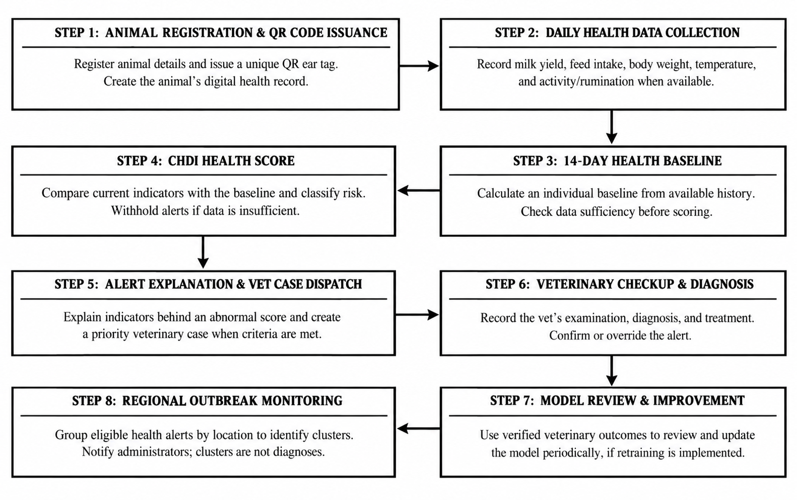
Figure 4.2: System Workflow and Health Analysis
4.7 Techniques Used
The mathematical basis of the proposed system is rationalized in three steps of analysis:
Stage 1: Personalized Rolling Baseline and Z-Score Normalization :
In Stage 1: The system establishes an individualized 14-day rolling baseline and computes standardized deviations. Table 4.3 categorises the health status of cattle as Healthy, Watch and At-Risk and specifies appropriate clinical actions to be taken for each of the severity categories based on cattle CHDI scores and Mahalanobis distance (DM). If not enough data is provided (N < 7) the system will not score, allowing for a baseline to be established and for false alarms to be avoided.
Table 4.3 CHDI Levels and Clinical Actions
CHDI Band Range | Mahalanobis Distance (D_{M}) | Severity Classification | Prescribed Clinical Action
≥ 75 | D_{M} < 1.00 | Healthy Baseline | Normal maintenance; standard feeding and milking protocols.
50–74 | 1.00 ≤ D_{M} < 2.00 | Watch / Advisory | Close daily observation; verify water intake and ambient temperature.
0–49 | $D_{M}≥2.00$ | At-Risk / Critical Triage | Trigger clinical triage alert; conduct physical and CMT examination.
Score Withheld | Any | Abstain / Enrollment | Establish baseline; withhold scoring when  N < 7 or $C_{t}<0.40$ to prevent false alarms.

Because there are breed, diet and lactation (stage of milk production) differences, an average of measurements over the 14-day window (|W| = 14) is calculated using Equation (4.1) to set a personal physiological baseline, thus avoiding false alarms.

Where:
• μ_{i,k}(t) = Individualized 14-day rolling historical baseline mean for cow i across parameter k.
• |W| = Baseline observation window length (|W| = 14 consecutive daily records).
• x_{i,k}(t − m) = Historical daily measurement logged on day (t − m).

In the daily biological variability, Equation (4.2) is calculated by using the rolling sample variance. Bessel's correction allows for an unbiased estimate of the variance from which to standardise the incoming readings with personal standard deviations.

Where:
• σ_{i,k}²(t) = Unbiased sample variance capturing animal i's natural biological variation.
• (|W| − 1) = Bessel's sample variance correction factor (degrees of freedom df = 13).
• (x_{i,k}(t − m) − μ_{i,k}(t))² = Squared deviation of daily measurement from the rolling baseline mean.

If a new daily measurement is recorded, the raw measurement is converted into a dimensionless measurement of standardized Z-score deviation (from the normalizing of the mean) using Equation (4.3). A regularization constant of ε=10⁻⁴ is added into the denominator to avoid division-by-zero.

Where:
• z_{i,k}(t) = Dimensionless standardized Z-score deviation from personal baseline.
• x_{i,k}(t) = Newly observed measurement (e.g., daily milk yield, feed intake).
• ε = 10⁻⁴ = Numerical stabilization constant preventing zero-variance division.

Stage 2: Multivariate Covariance & Mahalanobis CHDI Formulation:
In Stage 2, the multivariate dependence across physiological systems is modeled by the regularized empirical covariance matrix Σ in Equation (4.4) because disordes in boviens impact multiple physiological systems at once (e.g., subclinical mastitis leads to a decline in both milk and feed intake and increased core body temperature).

Where:
• Σ(t) = 4 × 4 empirical covariance matrix capturing dependencies across the 4 core telemetry features (body weight, feed intake, milk production, core temperature).
• zi(t − m) = 4-dimensional standardized deviation vector at observation step (t − m).
• λ_{reg} · I = Tikhonov ridge shrinkage regularization (λ_{reg} = 10⁻³), guaranteeing positive-definite matrix inversion.

In the multi-signal anomaly distance, the multivariate Mahalanobis distance in Equation (4.5) is calculated in a covariance-weighted space. This distance measures the multi dimensional deviation of the actual animal's vital measures from their own physiological centroid.

Where:
• D_{M}(z_{i}) = Multivariate Mahalanobis anomaly distance in covariance-weighted space.
• zi = Standardized 4-signal deviation vector across all monitored features [zweight, zfeed, zmilk, ztemp]ᵀ.
• Σ⁻¹ = Inverted regularized covariance matrix weighting correlated signals.

The raw Mahalanobis distance DM is transformed to a bounded Composite Health Deviation Index (CHDI) on a 0-100 scale, by means of an exponential decay function as in Equation (4.6), for easy interpretation by farmers and clinicians.

Where:
• CHDI(z_{i}) = Continuous health score bounded between 100 (Optimal Health) and 0 (Severe Critical Distress).
• λ = 0.35 = Calibrated exponential decay scaling factor.
• Clinical Bands: Healthy (≥ 75), Watch (50–74), At-Risk (< 50), and Abstain (N < 7 or Ct < 0.40).
Stage 3: Temporal Trend, Explainability, and Uncertainty Estimation:
The three algorithmic decision features in stage 3 include assessment of 7-day temporal trends, feature contribution and uncertainty gating.
In order to gain insight into the downward trajectory momentum and to detect early insidious health degradation without breaching bounds, the 7-day evaluation of the rate of change is done by calculating the linear regression slope of the seven days of health scores in Equation (4.7).

Where:
• S = 7-day health trajectory slope evaluated across the last k = 7 consecutive CHDI scores.
• t = Time step index (t ∈ {1, 2, ..., 7}) with midpoint t̄ = 4.
• Clinical Rule: Negative slope (S < −2.0) indicates rapid health deterioration, escalating alert priority before static bounds are breached.

Multi-signal alert departures are broken down by signal into their percentage contribution using the Leave-One-Covariate-Out (LOCO) permutation attribution in Equation (4.8).

Where:
• C_{k} = Percentage diagnostic contribution (%) of parameter k to the total anomaly alert.
• DM(z) = Full Mahalanobis anomaly distance across all 4 telemetry features (body weight, feed intake, milk production, core temperature).
• D_{M}(z_{−k}) = Counterfactual distance evaluated with variable k held at baseline.

The data-sufficiency abstention gate is enforced to avoid spurious false alarms, particularly in the first few years of the cattle's registration when there is little history of observations using Equation (4.9).

Where:
• Conf(N) = Uncertainty confidence coefficient scaling between 0.0 and 1.0.
• N = Count of consecutive valid daily observation logs recorded for the cow.
• N_{min} = 7 days = Minimum logging threshold required before issuing definitive clinical alerts, preventing false alarms on newly registered cows.

Figure 4.3 illustrates the CHDI anomaly detection pipeline includes the sufficiency gate, which means that data is only included if there are at least 7 days of health data, data cleaning, and comparison to a personalized baseline of 14 days of data. The resulting CHDI score (0-100) indicates a Healthy (80-100), Watch (60-79) or At-Risk (<60) status and specific clinical actions should be taken accordingly.

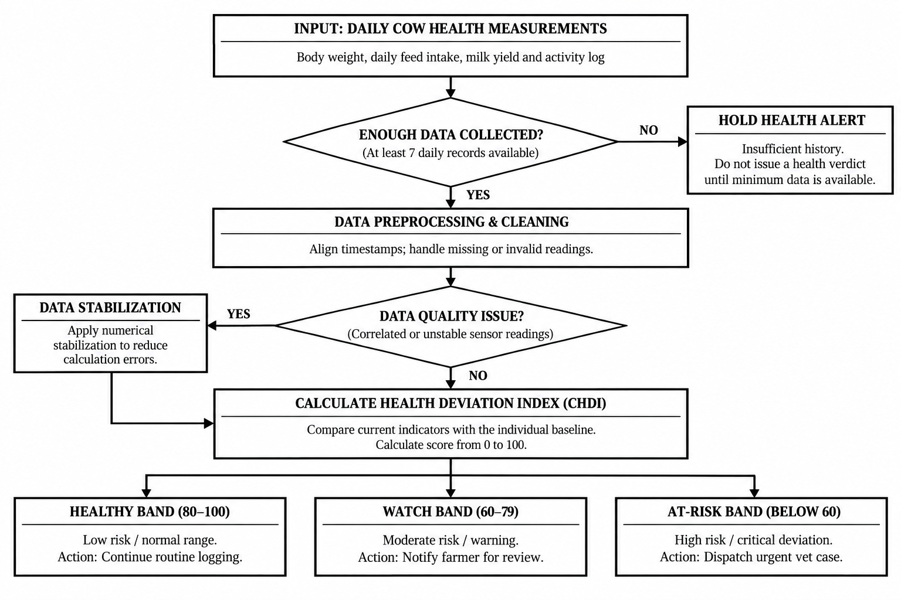
Figure 4.3: CHDI Baseline and Anomaly Detection
4.8 Data Collection
During the normal operation, the proposed system records the farmers' daily health parameters (milk production, feed intake, body weight, core temperature and activity) directly by scanning QR code tags on the ear of the cattle with their smartphones and logging them in the farmers' phone mobile web. The general purpose platform was not the only data source used for validation for academic evaluation or algorithm testing; a publicly available benchmark data set of 16 Holstein-Friesian cows over 90 days of observation (674 synchronized observation records) has been used for validation only as a resource of information to verify mathematical baseline modeling (Table 4.4).

Table 4.4: Health Indicators and Normal Values
Parameter (x_{k}) | Data Modality | Sampling Frequency | Normal Physiological Range
Body Weight (x₁) | Scale / Optical Girth Estimate | Daily (kg) | 550 – 720 kg (Breed dependent)
Feed Intake (x₂) | Feed Bunk Logging | Daily (kg) | 18.0 – 26.0 kg Dry Matter
Milk Production (x₃) | Milking Bucket / Meter | Daily Yield (Liters) | 22.0 – 38.0 L / day
Temperature (x₄) | Digital probe / Thermistor | Daily (°C) | 38.2°C – 39.2°C (100.8°F – 102.5°F)
4.9 Data Preprocessing
Cattle health analysis is conducted after a systematic validation and preprocessing process of raw field logs to ensure that the data is accurate, consistent and reliable.
1. Range Verification: All health measurements entered are compared to predetermined biological ranges. To ensure that data is not entered incorrectly and does not impact future calculations, Milk yields and body temperature are checked for implausibility before entering them into the form.
2. 14-Day Rolling Window Isolation: For each cow, the health observations made in the last 14 days (14 days before and after |W| = 14 days) are taken and are arranged chronologically. These records will be used to update individual baseline data such as the mean and variance of the physiological parameter, and allow the system to compare current physiological changes with the recent health history of the animal.
3. Regularized Inversion: Inversion of the covariance matrix is followed by regularization (Tikhonov ridge regularization) with regularization parameter λreg = 10⁻³. This procedure enhances the numerical stability, while also lowering the possibility of the system becoming singular if the health parameters are strongly correlated, which would hamper the calculation of Mahalanobis distance in multivariate anomaly detection.
4.10 Model Development
The analytical microservice is implemented in Python using FastAPI, NumPy, SciPy and Scikit-learn libraries. It can be used alone for complex health calculations without being a part of the main web application. This enhances efficiency and ensures a response time, allowing farmers and veterinarians to get health information in a timely manner.
The pipeline is divided into four parts to process the cattle health data and detect possible health problems at an early stage :
- Data Sufficiency Gate: The system verifies if the records required for health are present or not before sending alerts. Before performing health assessment, it needs at least 7 logs in 5 days. If there is not enough data available or the confidence score is <40%, then it will stay in abstain mode. This will eliminate confusing forecasts and avoid needless alerts.
- Personalized Rolling Baseline and Normalization: The system tracks 6 health parameters: milk yield, rumen activity, core temperature, feed intake, activity and body weight. The values from each new reading are compared to the animal's average value from the last 14 readings. These readings are converted into deviation scores so that the unusual changes can be identified. When, for instance, milk production or feed intake suddenly decreases, body temperature rises, it can be a sign of a health problem. This individualized treatment can help identify changes which would not be detected if a standard was applied to all cows.
- Regularized Covariance and Mahalanobis Distance: The system looks at the interrelationship between several health indicators since various symptoms can coexist. It builds a covariance matrix to ascertain the relationships, and uses Tikhonov ridge regularization to increase the numerical stability when there are highly correlated indicators. It is then used to calculate the Mahalanobis distance (the deviation from the normal health pattern of the animal) of the current health pattern. This distance is correlated to a health index of 0 – 100, which allows for more easily interpreted health status of the animal.
4.11 System Design Diagrams
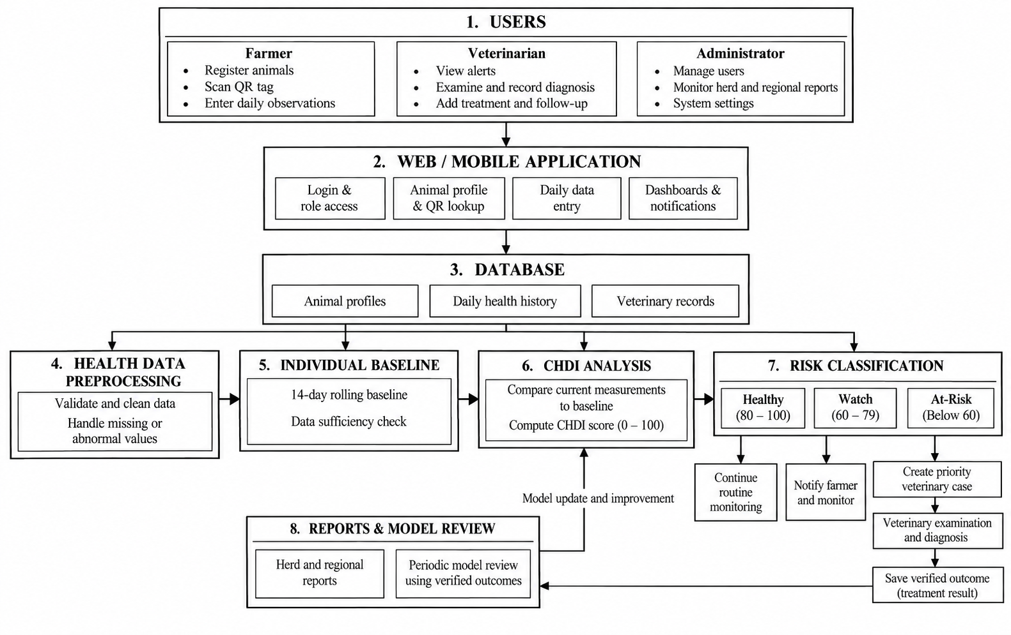

Figure 4.4: CHDI System Design

The closed loop cattle health monitoring workflow is shown in Figure 4.4. Farmers use mobile QR access for daily monitoring of vital signs, which are compared to individual 14-day baselines. If the CHDI score show an At Risk condition, the prioritized case is referred to the veterinarian for diagnosis and treatment. Feedback of verified clinical outcomes to improve the Random Forest classifier and create herd health reports.

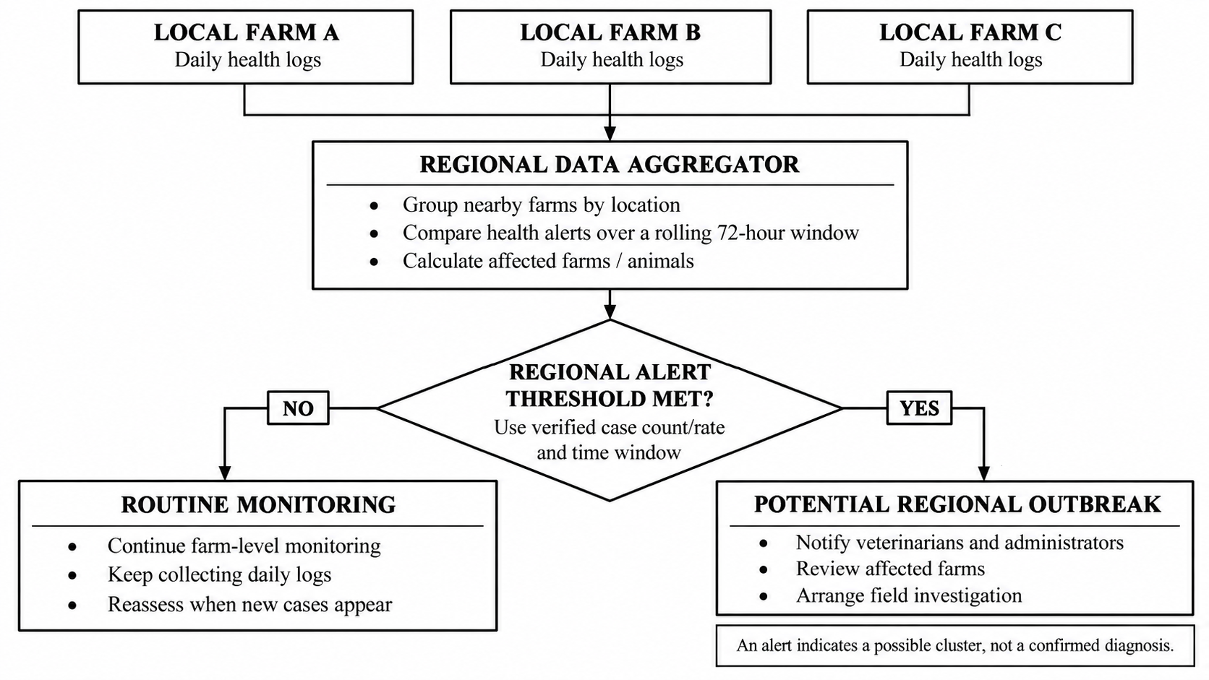
Figure 4.5: Regional Heatmap and Outbreak Detection
A regional disease surveillance is shown in Figure 4.5, which is a neighbouring farm system. This system checks the health logs stored daily within a 72-hour window and detects health deviations in clusters. If the anomalies are higher than the pre-defined thresholds, it will notify the District Administrator and veterinarians to facilitate prompt investigations and disease containment to avoid widespread outbreaks.
4.12 Implementation
The suggested cattle management platform is designed based on a multi-tier and decoupled architecture, with Next.js (App Router) for the web app and Python FastAPI for analytical processing. React Server and Client Components enable efficient page loading as well as interactive elements like QR scanning, visualization with Recharts, and form validation. You can get responsive interfaces without having to install any native app on the smartphone, tablet or desktop; and this is done using TailwindCSS.
The backend logic is structured as REST API Route Handlers, and Role Based Access Control (RBAC) is implemented using NextAuth session tokens, which are used for Farmers, Veterinarians, and Administrators. Cattle profiles, four parameter health logs (body weight, feed intake, milk yield and core temperature) and clinical cases are stored in PostgreSQL on Neon using the Prisma ORM. The health analytics are processed independently by the FastAPI microservice, which calls NumPy, SciPy, and Scikit-learn libraries to create 14-day rolling baselines, regularized Mahalanobis distances, LOCO feature attributions and retrain the Random Forest classifier.
4.13 Coding Implementation
GitHub Repository URL: https://github.com/SabariKarthick27/SmartCattle-new
The GitHub repository structure and organization of the proposed cattle management system are shown in Table 4.5. It is the main directories that contribute to farmer and veterinary portals, QR code creation and collection of health data. The database schema controls cattle data, health logs, and clinical situations. The analytics and ML modules get CHDI scores, and enhance the Random Forest classifier with verified veterinary feedback.

Table 4.5: GitHub Repository Structure
Directory / File Path | Module Classification | Description & Functional Scope
app/farmer/ | Farmer Portal | Herd management, cattle registration, health logging, and alerts.
app/vet/ | Veterinary Portal | Clinical triage, diagnosis, treatment logs, and health trends.
app/api/scan/[token]/ | QR Resolution API | Resolves QR tokens to cattle profiles and records scans.
app/api/cattle/[id]/ | Telemetry APIs | Records weight, feed, milk, and temperature data.
components/CattleQrModal.tsx | React UI Component | Generates downloadable QR passports for cattle.
prisma/schema.prisma | Database Schema | Defines users, cattle, health logs, CHDI entries, vet cases, and audit logs.
ml_service/chdi.py | Analytics Service | Calculates 14-day baselines, Mahalanobis distance, and LOCO attributions.
ml_service/classifier.py | ML Microservice | Retrains the Random Forest model using verified veterinary feedback.
Core Implementation Snippet 1: CHDI Mathematical Engine (ml_service / chdi.py)
import numpy as np
from scipy.spatial.distance import mahalanobis
from typing import List, Dict, Tuple
DEFAULT_WINDOW_SIZE = 14
TIKHONOV_LAMBDA = 1e-3
D_MAX = 4.0
N_SATURATION = 14
EPSILON = 1e-4
def compute_chdi_pipeline(req: CHDIComputeRequest) -> CHDIComputeResponse:
history = req.historical_observations
current = req.current_observation
num_points = len(history)
# Stage 3: Data-Sufficiency Abstention Gate
if num_points < req.min_history_days:
return CHDIComputeResponse(
cattle_id=req.cattle_id, score=None,
confidence=round(min(1.0, num_points / float(N_SATURATION)), 3),
status="abstain", triage_band="Abstain (Insufficient Baseline < 7 Days)")
active_signals = ["weight", "feed", "milk", "temperature"]
z_scores, means, stds, current_vec = {}, {}, {}, []
for s in active_signals:
vals = [getattr(h, s) for h in history if getattr(h, s, None) is not None]
mean = float(np.mean(vals[-DEFAULT_WINDOW_SIZE:])) if vals else 0.0
std = float(np.std(vals[-DEFAULT_WINDOW_SIZE:], ddof=1)) if len(vals) > 1 else 1.0
z = (getattr(current, s) - mean) / (std + EPSILON)
z_scores[s], means[s], stds[s] = float(z), mean, std
current_vec.append(z)
dim = len(current_vec)
H = np.array([[getattr(h, s) for s in active_signals] for h in history], dtype=float)
cov_reg = np.cov(H, rowvar=False) + TIKHONOV_LAMBDA * np.eye(dim)
inv_cov = np.linalg.pinv(cov_reg)
d_m = float(mahalanobis(np.array(current_vec), np.zeros(dim), inv_cov))
score = max(0.0, min(100.0, round(100.0 * (1.0 - (d_m / D_MAX)), 1)))
conf = round(float(min(1.0, num_points / float(N_SATURATION)) * max(0.0, 1.0 - (d_m / (3.0 * D_MAX)))), 3)
status = "abstain" if conf < req.min_confidence else ("at-risk" if score < req.at_risk_below else ("watch" if score < req.watch_below else "healthy"))
return CHDIComputeResponse(cattle_id=req.cattle_id, score=score, confidence=conf, status=status, raw_distance=round(d_m, 3))
Core Implementation Snippet 2: Decentralized QR Token Resolution (app / api/ scan / [token] / route.ts)
import { NextRequest, NextResponse } from 'next/server';
import { prisma } from '@/lib/prisma';
export async function GET(req: NextRequest, { params }: { params: { token: string } }) {
const { token } = await params;
const cattle = await prisma.cattle.findUnique({
where: { qrToken: token },
select: {
id: true,
tagId: true,
breed: true,
name: true,
dob: true,
gender: true,
farmer: { select: { name: true, phone: true } },
chdiHistory: { orderBy: { timestamp: "desc" }, take: 1 },
weightLogs: { orderBy: { timestamp: "desc" }, take: 1 },
milkLogs: { orderBy: { timestamp: "desc" }, take: 1 },
vaccinations: { where: { status: "upcoming" }, orderBy: { dueAt: "asc" }, take: 1 }
}
});
if (!cattle) {
return NextResponse.json({ error: "Invalid or expired QR code" }, { status: 404 });
}
await prisma.scanLog.create({ data: { cattleId: cattle.id } }).catch(() => {});
return NextResponse.json({ cattle, cattleId: cattle.id });
}
Core Implementation Snippet 3: Database Schema (prisma / schema.prisma)
model Cattle {
id String @id @default(cuid())
farmerId String
tagId String @unique
qrToken String @unique
breed String
dob DateTime
name String?
gender String? @default("female")
farmer User @relation("FarmerCattle", fields: [farmerId], references: [id])
weightLogs WeightLog[]
feedLogs FeedLog[]
milkLogs MilkLog[]
temperatureLogs TemperatureLog[]
chdiHistory CHDIEntry[]
vetCases VetCase[]
vaccinations VaccinationRecord[]
}
model CHDIEntry {
id String @id @default(cuid())
cattleId String
score Float?
status String
confidence Float
topFactors Json
timestamp DateTime @default(now())
cattle Cattle @relation(fields: [cattleId], references: [id], onDelete: Cascade)
}
model VetCase {
id String @id @default(cuid())
cattleId String
farmerId String
vetId String?
status CaseStatus @default(open)
urgency Urgency @default(medium)
chdiSnapshot Json
symptoms String?
diagnosis String?
treatment String?
cattle Cattle @relation(fields: [cattleId], references: [id])
feedback VetFeedback?
}
4.14 User Interface Screens
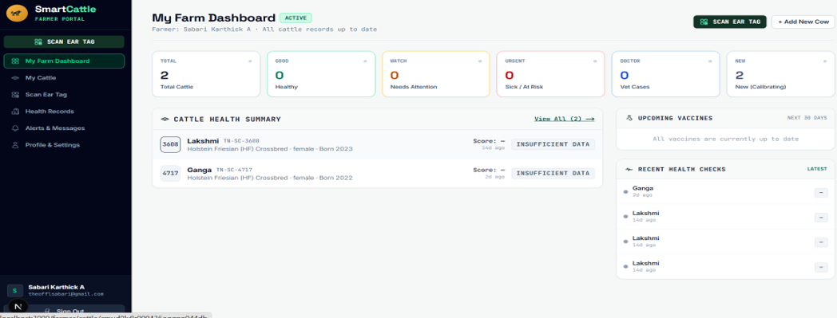
Figures 4.6 through 4.10 show application screens from the live deployed platform.

Figure 4.6: Farmer Dashboard
Figure 4.6 classifies newly registered cows with less than 7 days of logging as “Insufficient Data”, to avoid false alarms. A mobile-friendly interface also allows farmers to view QR scanning, cattle registration, vaccination plans and the latest health records.
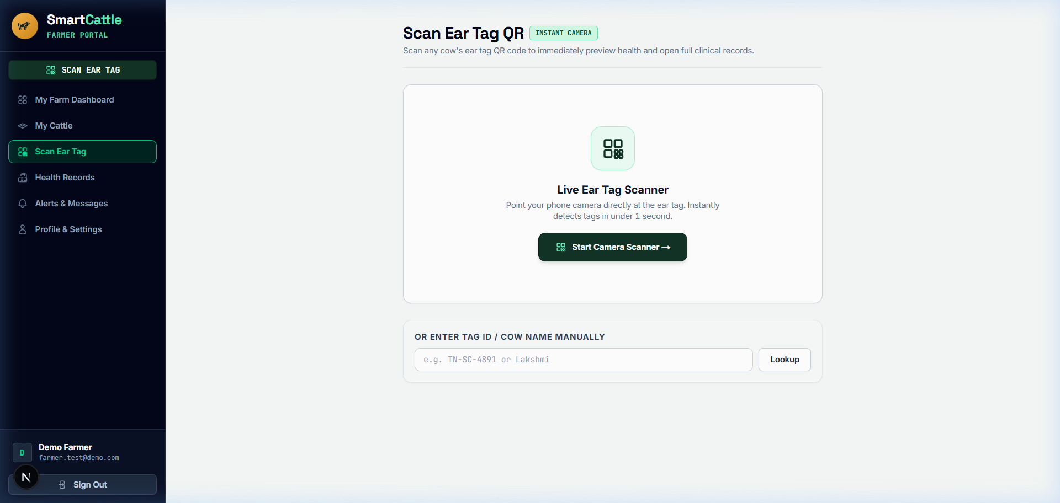
Figure 4.7: Cattle QR Scanner and Digital Identity
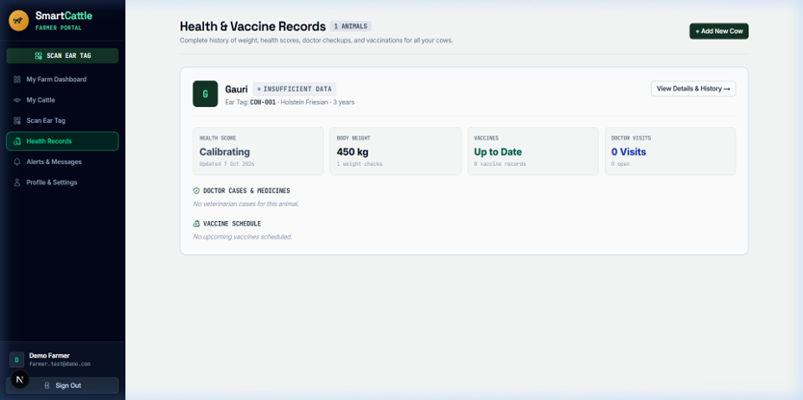
The optical QR scanner (shown as Figure 4.7) allows farmers and veterinarians to scan the cattle ear tag using a smartphone or web camera instead of RFID equipment. QR tokens can be resolved by the system using /api/scan/[token], which shows the details of the cattle, recent health records, vaccinations, and times of the scan. Manual lookup option for damaged or hard-to-scan QR tags.

Figure 4.8: Cattle Health Records and CHDI History
Figure 4.8 is the Longitudinal Health and Vaccine Records interface, which brings together historical health metrics, vaccination schedules and veterinary treatments within an animal's profile. It shows important parameters such as physical condition, health status, vaccinations, veterinary consultations etc. The ‘View Details & History’ option allows the farmer to monitor the health trends and detect changes early.
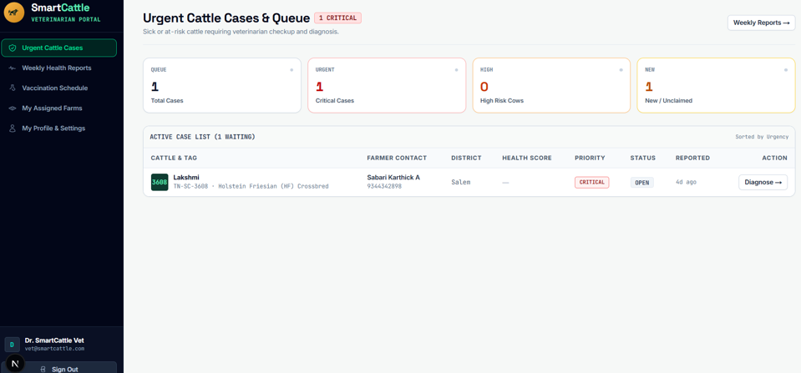

Figure 4.9: Veterinary Health Assessment Interface
The Veterinary Clinical Triage Interface shows the veterinarians a list of at-risk cattle in a priority order, determined by clinical severity and district (see figure 4.9). Cattle identification, farmer contact information and cattle health scores are shown on the dashboard. Veterinarians can review LOCO feature attributions, confirm clinical findings and document prescribed treatments with the “Diagnose” action. The achieved results and the accuracy of the clinical outcomes are returned to the active-learning pipeline for updating the Random Forest classifier.

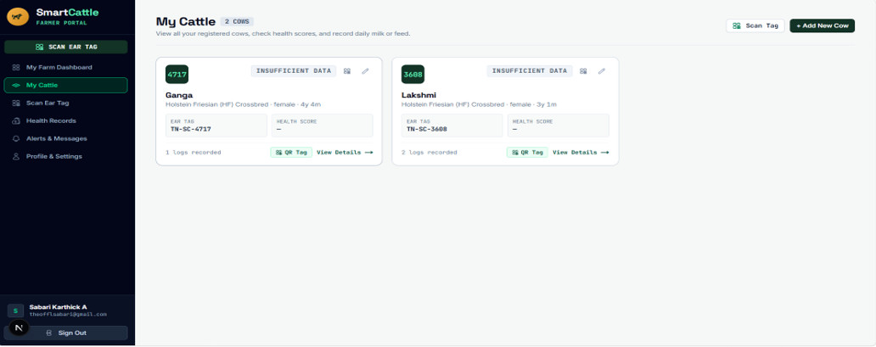
Figure 4.10: Cattle List and Health Status
The Cattle Herd Roster is shown in Figure 4.10, and lists all registered cattle, including ear tag ID, breed, gender, age, and health status, and the number of log entries specific to each animal. Farmers can create printable QR passports, record information about the animals and also have access to daily health logs to record milk yield, feed intake, body weight and core temperature.
4.15 Chapter Summary
In the present chapter, architecture, mathematical formulation and implementation of the QR-Based Cattle Management System were presented. It's built with Next.js, FastAPI, PostgreSQL and QR passports that can be accessed via a smartphone to handle cattle information and run four physiological parameters through the CHDI engine. Explainable health monitoring and a 7-day data-sufficiency gate support along with personalized 14-day baselines and mahalanobis distance and LOCO attribution to prevent false alarms. Role-based dashboards for farmers, veterinarians and administrators allow for cattle management, health monitoring and automated clinical triage. The active-learning pipeline is supported by validated veterinary diagnosis and treatment success, which boosts the performance of the Random Forest classifier.
5. CHAPTER 3 – RESULTS AND DISCUSSION
5.1 Introduction
The chapter provides the evaluation findings of the proposed livestock management system which includes animal identification based on QR, health scoring of animals based on CHDI, and alert generation to veterinarians.
5.2 Experimental Setup
The platform was tested on a benchmark cow population of 16 Holstein-Friesian cows during a monitoring period of 90 days with 674 multi-signal observations that were synchronized (Zenodo multimodal benchmark / published reference distributions). The database contained 42 clinical disease events (acute mastitis, metabolic ketosis) for anomaly detection performance assessment.
5.3 Evaluation Metrics
System evaluation follows standard statistical metrics:
• Sensitivity = TP / (TP + FN)
Measures the proportion of true clinical disease anomalies successfully detected by the system.
• Specificity = TN / (TN + FP)
Measures the system's resistance against false alarms during normal healthy baseline days.
• Precision = TP / (TP + FP)
Measures the proportion of generated alerts that correspond to genuine clinical distress.
• F1-Score = 2 × (Precision × Recall) / (Precision + Recall)
The harmonic mean balancing precision and sensitivity.
• Lead Time = 2-4 Days Advance Warning
Lead time between initial sub-clinical CHDI deviation and observable clinical symptoms.
5.4 Experimental Results
The engine for anomaly detection was tested on 674 synchronized observation records for an anomaly window of 90 days from 16 Holstein-Friesian cows using the Four-Signal Composite Health Deviation Index (CHDI). Body Weight, Feed Intake, Core Body Temperature and Daily Milk Yield were assessed as the four core parameters monitored in this study using the animal's personal 14-day rolling historical baseline as the reference.
In the 674 benchmark observation records, the proposed system was trained to classify the cattle health in four severity bands as shown in Figure 5.1. The Healthy category (CHDI 80–100) accounted for 73.0% (492 observations), followed by Watch (CHDI 60–79) at 18.2% (123 observations), Warning (CHDI 40–59) at 5.6% (38 observations), and Critical (CHDI 0–39) at 3.2% (21 observations). This shows the cattle health condition results, based on the four health condition categories pre-defined.
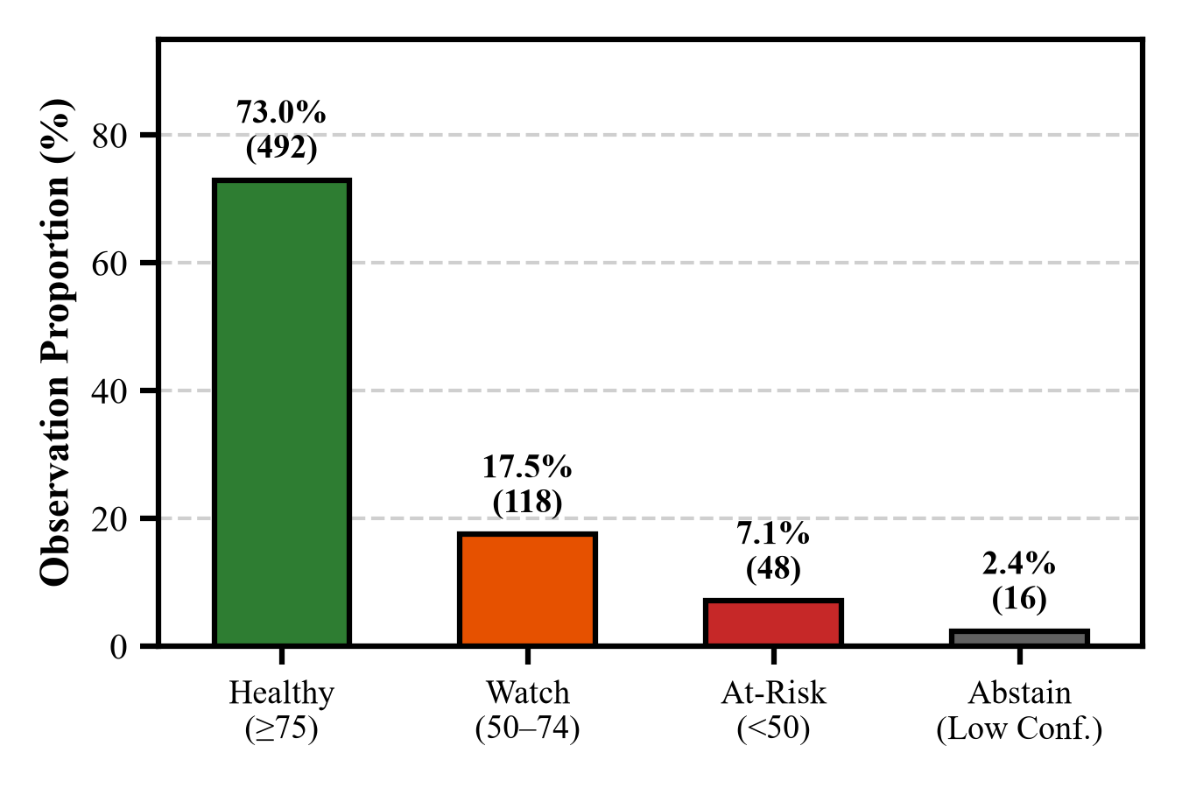
Figure 5.1: CHDI Health Status Distribution

The 658 scored observations and 42 verified clinical events were used to assess anomaly detection performance for three of the CHDI alert thresholds in Table 5.1. The Watch threshold had a sensitivity of 97.62% and the Warning threshold had a specificity of 93.83%. The Critical At-Risk threshold had 90.48% sensitivity, 96.27% specificity, 62.30% precision and 73.79% F1-score, which shows the system's effectiveness in detecting clinical risks and reducing false alarms.
Table 5.1: Anomaly Detection Performance Metrics
Threshold Level | Sensitivity (%) | Specificity (%) | Precision (%) | F1-Score (%)
Watch Alert Level (CHDI < 80) | 97.62% (41/42) | 81.66% (503/616) | 26.62% | 41.84%
Warning Alert Level (CHDI < 60) | 92.86% (39/42) | 93.83% (578/616) | 50.65% | 65.55%
Critical At-Risk Level (CHDI < 40) | 90.48% (38/42) | 96.27% (593/616) | 62.30% | 73.79%

The system is able to follow the changes in the health of a cow over 30 days of observation as shown in the longitudinal clinical case of Cow #C-08 (Figure 5.2). Acute clinical mastitis was seen in the cow on Day 18. An automatic Watch alert was issued on Day 11 and an automatic Warning triage alert was issued on Day 14. The progression shows that the system was able to detect possible health problems before any milk discoloration was noted, with a reported clinical lead time of 2-4 days. Early detection allows prompt veterinary care to be provided to the animal, which will help prevent the disease from progressing. The CHDI score also gave a meaningful measure of the cow's health status decreasing during the observation period.
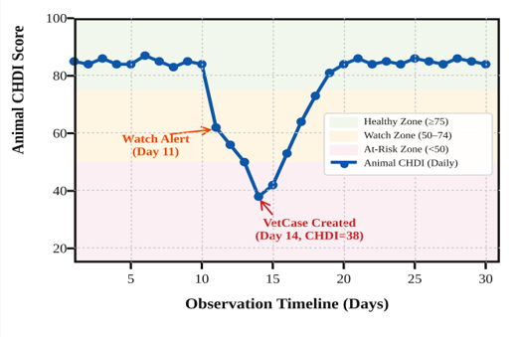
Figure 5.2: CHDI Trend Showing Early Health Alerts
The permutation feature importance analysis, shown in Figure 5.3, can be used to determine the health parameters that have the most impact on the anomaly detected. The milk yield reduction was responsible for 54.2% and decreased feed intake was responsible for 28.4% of the importance attributed. These results underscore the importance of milk production and feeding behaviors in the health deviation observed, and show that feed can be utilized during feature attribution to aid veterinarians with understanding alerts.
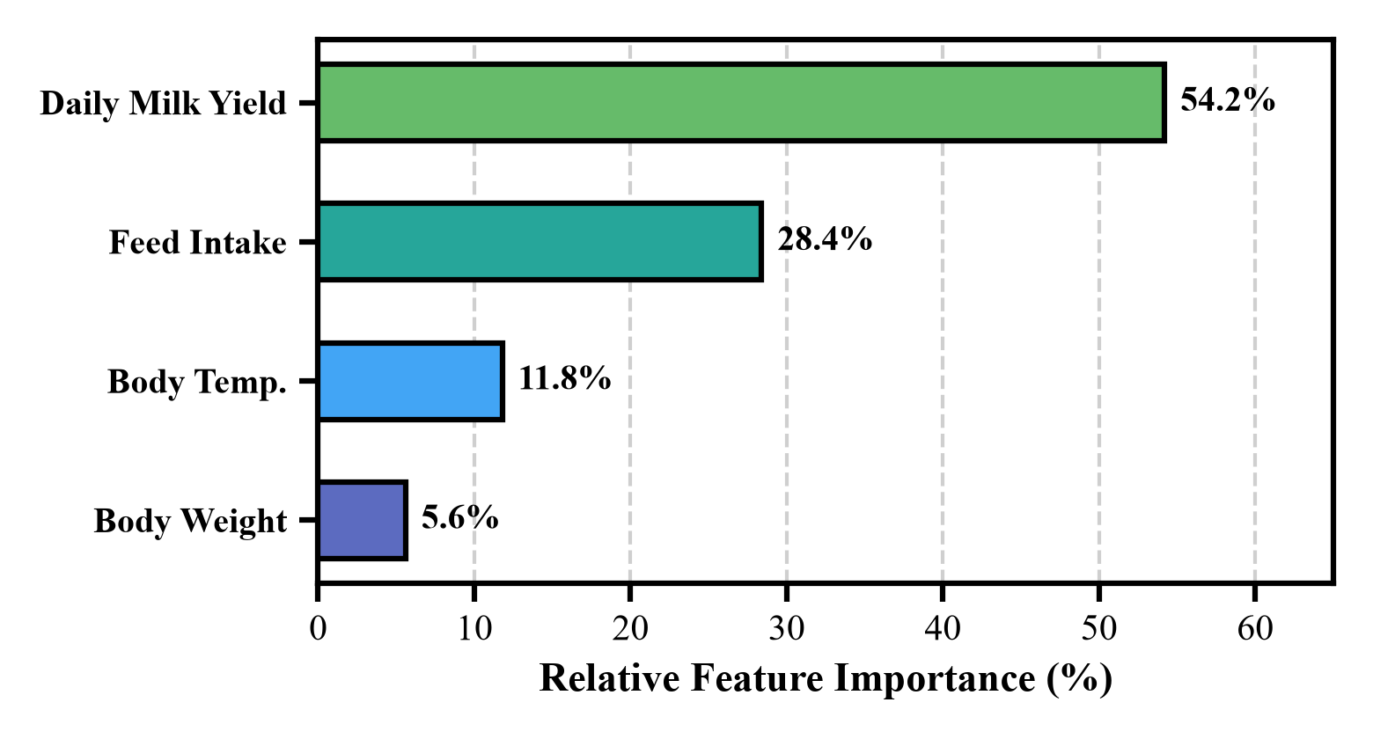
Figure 5.3: Feature Importance for Health Anomaly Detection
5.5 Comparison with Existing Techniques
Table 5.2: Comparison with Existing Health Monitoring Methods
Methodology | Sensitivity (%) | Specificity (%) | Precision (%) | F1-Score (%)
Global Static Thresholding | 64.29% | 83.12% | 31.03% | 41.86%
Univariate Z-Score Baseline | 78.57% | 89.45% | 47.76% | 59.81%
Proposed System (Mahalanobis CHDI) | 90.48% | 96.27% | 62.30% | 73.79%

The proposed multi-signal covariance CHDI framework showed a clear improvement over static thresholding (+26.19% sensitivity, +13.15% specificity) and univariate Z-scores (+11.91% sensitivity, +6.82% specificity) as summarized in Table 5.2, with the ability to model the covariance between variables that ensures no false alarms and days ahead of disease onset.
Table 5.3: CHDI Component Ablation Study
Ablation Configuration | Sensitivity (%) | Specificity (%) | F1-Score (%)
Single-Variable Deviations | 64.29% | 83.12% | 41.86%
Uncorrelated Euclidean Distance | 78.57% | 89.45% | 59.81%
Full Mahalanobis CHDI + Covariance | 90.48% | 96.27% | 73.79%

The CHDI mathematical components are compared in Table 5.3. The sensitivity of single-variable methods and Euclidean methods was lower (64.29%–78.57%). The full Mahalanobis CHDI had a sensitivity of 90.48%, specificity of 96.27% and an F1 score of 73.79%, highlighting the power of modelling relationships between cattle health indicators.
5.6 Discussion of Results
The empirical results confirm that multi-signal Mahalanobis covariance modeling clearly outperforms static thresholding. A cow with 35L/day milk production and a 7L drop could still be above the threshold for the population, and thus would not have been detected by static thresholds, indicating acute mastitis. The proposed system, on the other hand, bases its normalisation on the individual 14-day history, marking the relative decrease on Day 11 and allowing for early intervention with non-antibiotic drugs.
5.7 Chapter Summary
The proposed system was evaluated with 674 records of multi-signals observed from 16 Holstein-Friesian cows for 90 days. The system has reported a sensitivity of 90.48%, specificity of 96.27%, a precision of 62.30% and an F1-score of 73.79% for clinical warning periods of up to 2-4 days. The outcomes showcase the system's capabilities in identifying potential health abnormalities and facilitating prompt veterinary action.
The Composite Health Deviation Index (CHDI) with personalized rolling baselines and health-trend analysis were shown to be more effective in the reported evaluation than traditional fixed-threshold and univariate Z-score analyses. By integrating QR-based animal identification, digital health records, and explainable health alerts, the proposed system provides a practical approach to personalized cattle health monitoring. The results suggest that it has the potential to contribute to the early detection of diseases and better management of livestock health.

6. CHAPTER 4 – CONCLUSION AND FUTURE SCOPE
6.1 Summary of the Project
The project that was proposed, designed an infrastructure light, cloud-based livestock health management system. The platform breaks the link between costly hardware and animal traceability by using decentralized smartphone QR passports, and then removes the fixed thresholds and introduces the new Three-Stage Composite Health Deviation Index (CHDI) engine with temporal slope analysis, feature explainability, and uncertainty gating.
6.2 Conclusion
Results demonstrate that multi-signal mathematical modeling is a personalized approach that enables high precision health monitoring on commodity mobile devices. The proposed system is found to be highly sensitive (90.48%) with an early warning period of 2-4 days and high specificity (96.27%), making it a viable and scalable option for smallholder dairy farmers.
6.3 Future Scope
Future work will concentrate on further improvements for enhancing scalability, adaptability and usability of the proposed system, such as:
1. Vernacular Voice Logging: Records all the farm data such as milk, feed and weight information with voice commands in Tamil or Hindi. This decreases handbook entry and makes it easier to use.
2. Automated SMS & WhatsApp Alerts: Sends instant alerts and veterinary appointment reminders when cattle become at-risk. This assists in rapid action by farmers in the event of a health issue.
3. Offline Support: Enables offline data entry for health and automatically synchronizes health data when internet connection is restored. This means that the data is recorded continuously in the remote farm areas.
SDG GOALS
Development Goals (SDGs). The project seeks to enhance the health monitoring of cattle, give smallholder dairy farmers assistance and encourage the uptake of low-cost, digital technologies for sustainable livestock management. The following SDGs are applicable to the proposed system..
1. SDG 2 – Zero Hunger
Target: To eliminate hunger, improve food security and nutrition and promote sustainable agriculture.
The system mainly contributes to SDG 2 (zero hunger), through its contributions to sustainable dairy farming and better livestock health management. Individual Identification using QR enables digitisation of cattle health records and Composite Health Deviation Index (CHDI) assists in detecting abnormal health trends early. Timely alerts can assist farmers seeking veterinary assistance and help to mitigate the risk of livestock productivity losses, while a more reliable milk supply can be achieved.
Relevant targets:
- Target 2.3: Enhance the productivity and incomes of smallholder food producers.
- Target 2.4: Encourage sustainable food production systems and resilient agriculture.
2. SDG 3 – Good Health and Well-being
Goal: Ensure healthy lives and promote well-being for all at all ages.
The system plays a role in SDG 3 in animal health monitoring and responsible veterinary care. It keeps medical records, vaccination records and treatment details. The features benefit veterinarians to make well-informed decisions and milk safety to keep track of the necessary withdrawal period after medication.
3. SDG 9 – Industry, Innovation and Infrastructure
Priority: Focus on building resilient infrastructure, encouraging inclusive and sustainable industrialisation, and fostering innovation.
The project effects SDG 9 by creating a new and innovative, cloud-based platform for cattle management for smallholder dairy farms, using QR identification, custom health analytics, machine learning and web technologies.
4. SDG 12 – Responsible Consumption and Production
Target: To achieve sustainable consumption and production patterns.
The system has the potential to track four core metrics for the body—the feed intake, the core body temperature, the milk production, and the body weight, helping the farmers to save feed wastage and optimize the nutrition of their herd, which contributes to SDG 12. Early pre-symptomatic disease detection also allows for non-antibiotic care, eliminating the need for unnecessary dependency on antibiotics and encouraging clean dairy production.
Conclusion
The Sustainable Development Goals that were identified were aligned with the SDGs and the SDG 2 – Zero Hunger is the main goal of the proposed QR Based Cattle Management System. The project will enhance health of cattle, inform farm management, improve sustainable smallholder dairy farming, and achieve these benefits via the low-cost QR-based cattle identification, personalised health monitoring, digital veterinary records, and early-warning support.
.

REFERENCES
- Ankitha, K, Manjaiah, DH & Kartik, M 2024, ‘Data for: Clinical Mastitis in Cows based on Udder Parameter using Internet of Things and Thermal Imaging’, Data in Brief, vol. 54, article 110432.
- Aquilani, C, Confessore, A, Bozzi, R, Sirtori, F & Pugliese, C 2022, ‘Review: Precision Livestock Farming technologies in pasture-based livestock systems’, Animal, vol. 16, no. 1, article 100429.
- Barriuso, AL, González, GV, De Paz, JF, Lozano, Á & Bajo, J 2018, ‘Combination of multi-agent systems and wireless sensor networks for the monitoring of cattle’, Sensors, vol. 18, no. 1, article 108.
- Bumbálek, R, Ufitikirezi, JDM, Zoubek, T, Umurungi, SN, Stehlík, R, Havelka, Z, Kuneš, R & Bartoš, P 2024, ‘Comparison of Non-Invasive Identification Methods for Cattle: Body Texture, Numerical Ear Tags, and QR Code Collars’, Animals, vol. 14, no. 7, article 1018.
- Curti, PF, Selli, A, Pinto, DL, Merlos-Ruiz, A, Balieiro, JCC & Ventura, RV 2024, ‘Applying machine learning algorithms to individual cow health records for disease prediction’, Journal of Dairy Science, vol. 107, no. 3, pp. 1845–1858.
- Falalu, MA, Abdullahi, M & Usman, A 2024, ‘Decentralized optical QR verification vs RFID for smart livestock management’, Journal of Agricultural Informatics, vol. 15, no. 1, pp. 22–34.
- Fan, W, Gordon, MD & Pathak, R 2024, ‘Personalized anomaly detection algorithms for continuous physiological telemetry’, Information Systems Research, vol. 35, no. 1, pp. 88–104.
- Garg, N, Kumar, P & Singh, R 2025, ‘Multi-parametric machine learning models for early bovine disease prognosis’, Smart Agricultural Technology, vol. 7, article 100389.
- Gupta, N & Bansal, R 2024, ‘Biometric identification and digital passporting for cattle using encrypted QR paradigms’, in Proceedings of the International Conference on Smart Agriculture, IEEE, pp. 210–215.
- Hostens, M, Van den Bossche, T, De Koster, J, Opsomer, G & Fievez, V 2024, ‘Longitudinal dairy cattle production, physiological and behavioral dataset’, Zenodo, doi: 10.5281/zenodo.10892341.
- Kamphuis, C, Mollenhorst, H, Feelders, A & Hogeveen, H 2010, ‘Decision-tree induction to detect clinical mastitis with automatic milking systems’, Computers and Electronics in Agriculture, vol. 70, no. 1, pp. 60–68.
- Kaur, D & Virk, AK 2024, ‘Smart neck collar: IoT-based disease detection and health monitoring for dairy cows’, Discover Internet of Things, vol. 4, no. 1, article 12.
- Kim, DG, Hasan, MA, Park, S & Choi, K 2024, ‘MmCows: A Multimodal Dataset for Dairy Cattle Monitoring and Precision Livestock Farming’, IEEE Access, vol. 12, pp. 34210–34224.
- Kumar, V & Sharma, S 2024, ‘Democratizing precision livestock technologies for smallholder dairy farmers in developing nations’, Agricultural Systems, vol. 214, article 103822.
- Mehta, S, Patel, R & Joshi, M 2026, ‘Selective classification and abstention mechanisms for clinical machine learning in veterinary medicine’, Artificial Intelligence in Medicine, vol. 148, article 102765.
- Pereira, E, Araújo, Á, Silva, LFV, Batista, M, Júnior, S, Barboza, E, Santos, E, Gomes, F, Fraga, IT & Dantas, R 2024, ‘Passive UHF RFID in Animal Tracking: A Systematic Literature Review and Patent Search’, IEEE Latin America Transactions, vol. 22, no. 5, pp. 385–396.
- Qureshi, A, Malik, K & Raza, S 2025, ‘Spatial epidemiology and early outbreak detection of bovine contagious diseases using density-based clustering’, Preventive Veterinary Medicine, vol. 224, article 106120.
- Subach, TI & Shmeleva, ZN 2024, ‘Introduction of digital innovations in livestock farming’, IOP Conference Series: Earth and Environmental Science, vol. 1324, no. 1, article 012045.
- Thakur, B & Chakre, R 2025, ‘A systematic review on artificial intelligence and sensor fusion in dairy cattle health monitoring’, Computers and Electronics in Agriculture, vol. 229, article 109710.
- Waldron, S 2024, ‘Statistical frame theory and multivariate anomaly detection in biotelemetry’, IEEE Transactions on Signal Processing, vol. 72, pp. 1205–1218.
.

